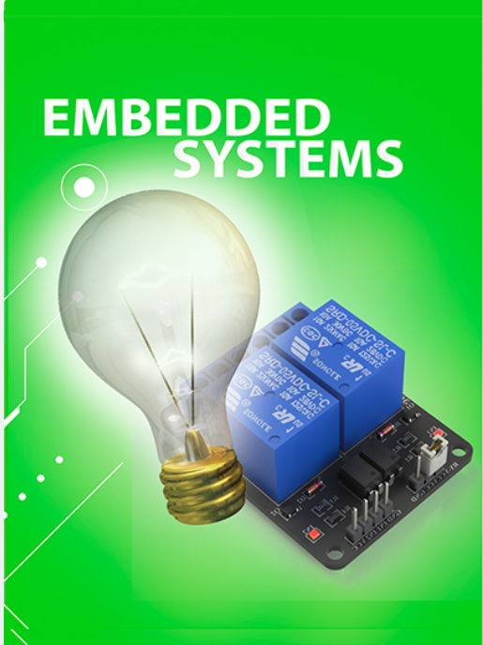CONTROL BULB USING RELAY WITH CONTROLLER

DOCUMENTATION ON
CONTROL BULB USING RELAY WITH CONTROLLER

Table of content
S.NO. | Index
1. | Introduction  1.1.abstract  1.2.hardware components.  1.3.Relay.
2. | Stage 1  2.1.hardware components.  2.2.connection  2.3.source code.  2.4.pin diagram  2.5.output diagram
3. | Stage 2 (RUGGED BOARD)  3.1.hardware components  3.2.connection.  3.3.source code.  3.4.pin diagram  3.5.output diagram
4. | Stage 3 (SEND DATA TO THINGSBOARD)  4.1.hardware components  4.2.connection.  4.3.Thingsboard  4.3.source code.  4.4.output diagram
5. | conclusion

1.INTRODUCTION

Abstract:
This abstract presents an innovative approach to bulb control using a relay-based system that enhances energy efficiency and user convenience. The proposed system employs a microcontroller to intelligently manage the operation of a light bulb through a relay switch.
Hardware Components
1.Relay
2.STM32 microcontroller.
3.Jumpers.
4.bulb. (230v)
5.Rugged board.
Relay
A relay is a switch which is electrically operated by an electromagnet. This relay has two channels. This means it can control two high voltage devices. The relay has two sides. One connects to the high voltage device and the other side connects to the controller. The side that controls the high voltage device has 3 pins. The common pin (COM), normally open pin (NO), and normally closed pin (NC).
1.COM : The common pin
2.NC (Normally Closed): The normally closed configuration is used when you want the relay to be closed by default, this means that the current is flowing unless you send a signal from the STM32 microcontroller to open the circuit.
3.NO (Normally Open): The normally open configuration works the other way around: the relay is always open, so this means that the circuit is broken and the current is not flowing unless you send a signal from the STM32 microcontroller to close the circuit (this is the configuration we will use).
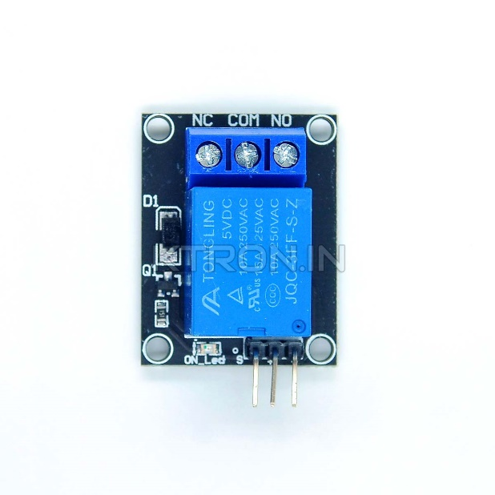

2.STAGE 1:
This abstract presents an innovative approach to bulb control using a relay-based system that enhances energy efficiency and user convenience. The proposed system employs a microcontroller to intelligently manage the operation of a light bulb through a relay switch
2.1.Hardware Components
1.Relay.
2.STM32 microcontroller.
3.Bulb.
2.2.Connection:
- Now let’s talk about the side that connects to the STM32 microcontroller. it has 3 pins
1.VCC (5V).
2.GND.
3.SIGNAL.
These 3 pins are connected to the microcontroller as shown in below.
- VCC -> 5V
- GND -> GND
- SIGNAL -> PA0 (PIN GPIOA pin as output )

- Now let’s talk about the another side that connects to the bulb. it has 3 pins .
1.COM
2.NO
3.NC.

The connections for the relay is simple. We take a wire from the light bulb and cut it so that we have two separate wires just like it is shown in the picture below. Then we put one wire into the NO (normally open) pin of the relay, and the other wire into the COM (common) pin of the relay.

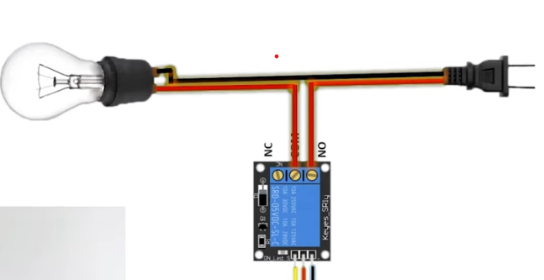
Fig 1: connection between relay with bulb

2.3.Source code for interface stm32 to relay
#include "main.h"
void SystemClock_Config(void);
static void MX_GPIO_Init(void);
static void MX_USART2_UART_Init(void);
UART_HandleTypeDef huart2;
int main(void)
{
HAL_Init();

/* Configure the system clock */
SystemClock_Config();
MX_USART2_UART_Init();
/* Initialize all configured peripherals */
MX_GPIO_Init();
while (1)
{
HAL_GPIO_WritePin(GPIOA, GPIO_PIN_0, GPIO_PIN_SET);
snprintf(uartTxBuffer, sizeof(uartTxBuffer), "LED is ON \r\n",)
HAL_Delay(2000);
HAL_GPIO_WritePin(GPIOA, GPIO_PIN_0, GPIO_PIN_RESET);
snprintf(uartTxBuffer, sizeof(uartTxBuffer), "LED is OFF \r\n",)
HAL_Delay(2000);
}
}
void SystemClock_Config(void)
{
RCC_OscInitTypeDef RCC_OscInitStruct = {0};
RCC_ClkInitTypeDef RCC_ClkInitStruct = {0};

__HAL_RCC_PWR_CLK_ENABLE();
__HAL_PWR_VOLTAGESCALING_CONFIG(PWR_REGULATOR_VOLTAGE_SCALE3);
RCC_OscInitStruct.OscillatorType = RCC_OSCILLATORTYPE_HSI;
RCC_OscInitStruct.HSIState = RCC_HSI_ON;
RCC_OscInitStruct.HSICalibrationValue = RCC_HSICALIBRATION_DEFAULT;
RCC_OscInitStruct.PLL.PLLState = RCC_PLL_ON;
RCC_OscInitStruct.PLL.PLLSource = RCC_PLLSOURCE_HSI;
RCC_OscInitStruct.PLL.PLLM = 16;
RCC_OscInitStruct.PLL.PLLN = 336;
RCC_OscInitStruct.PLL.PLLP = RCC_PLLP_DIV4;

RCC_OscInitStruct.PLL.PLLQ = 2;
RCC_OscInitStruct.PLL.PLLR = 2;
if (HAL_RCC_OscConfig(&RCC_OscInitStruct) != HAL_OK)
{
Error_Handler();
}
RCC_ClkInitStruct.ClockType = RCC_CLOCKTYPE_HCLK|RCC_CLOCKTYPE_SYSCLK
|RCC_CLOCKTYPE_PCLK1|RCC_CLOCKTYPE_PCLK2;
RCC_ClkInitStruct.SYSCLKSource = RCC_SYSCLKSOURCE_PLLCLK;
RCC_ClkInitStruct.AHBCLKDivider = RCC_SYSCLK_DIV1;
RCC_ClkInitStruct.APB1CLKDivider = RCC_HCLK_DIV2;
RCC_ClkInitStruct.APB2CLKDivider = RCC_HCLK_DIV1;
if (HAL_RCC_ClockConfig(&RCC_ClkInitStruct, FLASH_LATENCY_2) != HAL_OK)
{
Error_Handler();
}
}
static void MX_USART2_UART_Init(void)
{
huart2.Instance = USART2;
huart2.Init.BaudRate = 115200;
huart2.Init.WordLength = UART_WORDLENGTH_8B;
huart2.Init.StopBits = UART_STOPBITS_1;
huart2.Init.Parity = UART_PARITY_NONE;
huart2.Init.Mode = UART_MODE_TX_RX;
huart2.Init.HwFlowCtl = UART_HWCONTROL_NONE;
huart2.Init.OverSampling = UART_OVERSAMPLING_16;

if (HAL_UART_Init(&huart2) != HAL_OK)
{
Error_Handler();
}
/* USER CODE BEGIN USART2_Init 2 */

/* USER CODE END USART2_Init 2 */

}
static void MX_GPIO_Init(void)
{
GPIO_InitTypeDef GPIO_InitStruct = {0};
__HAL_RCC_GPIOA_CLK_ENABLE();
HAL_GPIO_WritePin(GPIOA, GPIO_PIN_0, GPIO_PIN_RESET);
/*Configure GPIO pin : PA0 */
GPIO_InitStruct.Pin = GPIO_PIN_0;
GPIO_InitStruct.Mode = GPIO_MODE_OUTPUT_PP;
GPIO_InitStruct.Pull = GPIO_NOPULL;
GPIO_InitStruct.Speed = GPIO_SPEED_FREQ_LOW;
HAL_GPIO_Init(GPIOA, &GPIO_InitStruct);
}
void Error_Handler(void)
{
__disable_irq();
while (1)
{
}
}

#ifdef USE_FULL_ASSERT
/**
* @brief Reports the name of the source file and the source line number
* where the assert_param error has occurred.
* @param file: pointer to the source file name
* @param line: assert_param error line source number
* @retval None
*/
void assert_failed(uint8_t *file, uint32_t line)
{
/* User can add his own implementation to report the file name and line number,
ex: printf("Wrong parameters value: file %s on line %d\r\n", file, line) */
/* USER CODE END 6 */
}
#endif /* USE_FULL_ASSERT */
2.4.Pin diagram to interface stm32 with relay is connected to bulb:

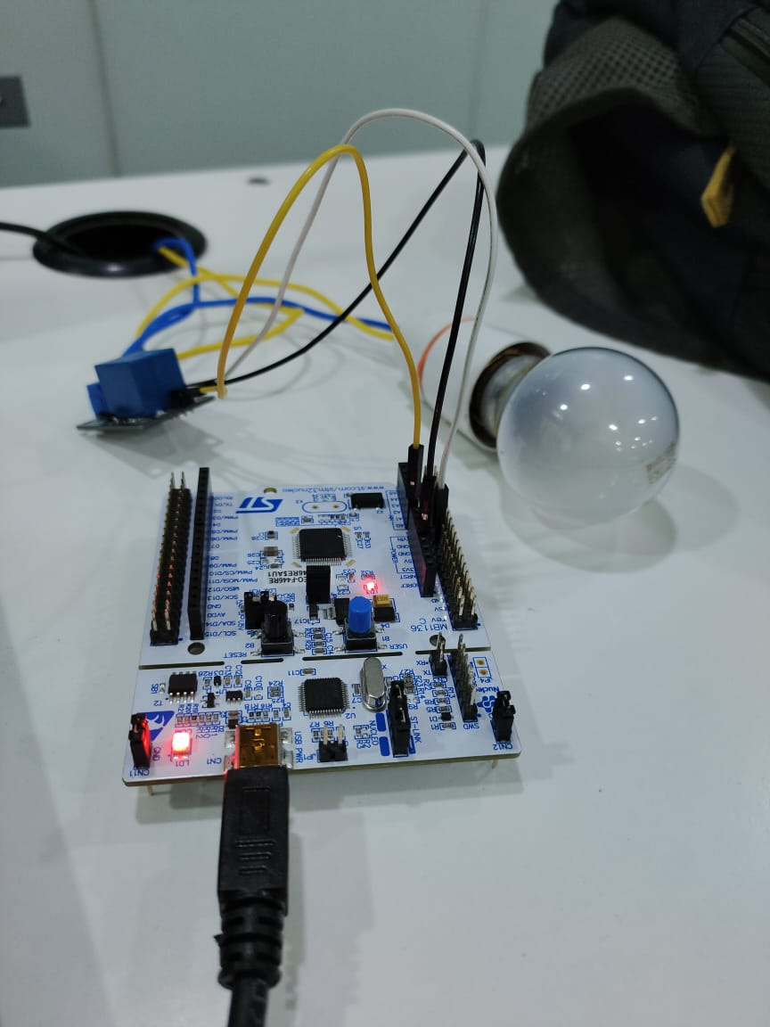

2.5.Output diagram:
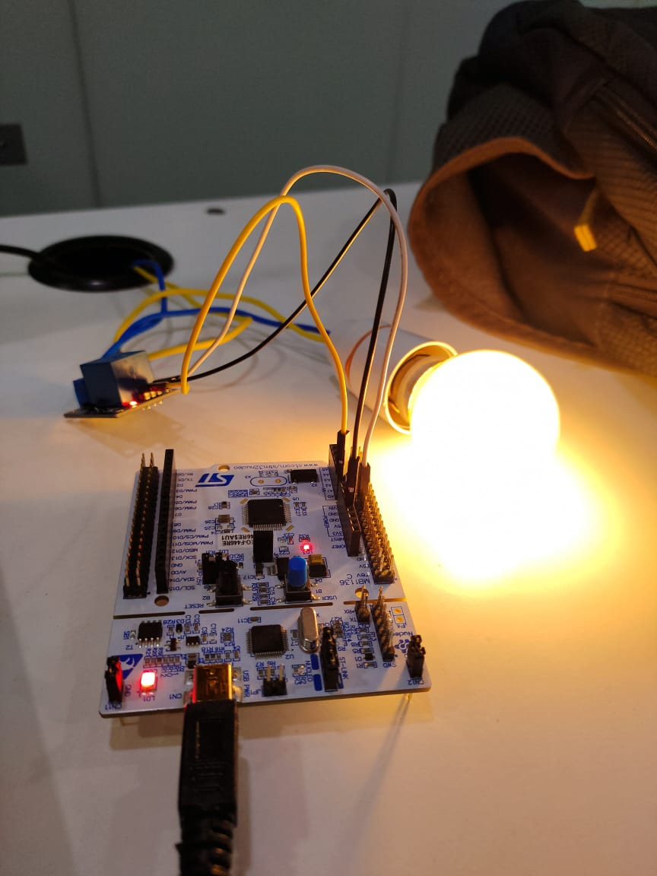

3.STAGE 2
This abstract presents an innovative approach to bulb control using a relay-based system that enhances energy efficiency and user convenience. The proposed system employs a rugged board to intelligently manage the operation of a light bulb through a relay switch.
3.1.Hardware Components
1.Relay.
2.Rugged board.
3.Bulb.

3.2.Connection:
- Now let’s talk about the side that connects to the Rugged board. it has 3 pins
These 3 pins are connected to the microcontroller as shown in below.
- VCC -> 5V
- GND -> GND
- SIGNAL -> PC23 (PIN GPIOA pin as output )

- Now let’s talk about the another side that connects to the bulb. it has 3 pins .
1.COM
2.NO
3.NC.
The connections for the relay is simple. We take a wire from the light bulb and cut it so that we have two separate wires just like it is shown in the picture above as per (fig1) . Then we put one wire into the NO (normally open) pin of the relay, and the other wire into the COM (common) pin of the relay.

3.3.Source code for Rugged board
FOR GETTING EXEC FILE GIVE THE BELOW COMMANDS:
1. enable the tool chain
2. ${CC} <filename.c> -o <exec file name> -lpaho-mqtt3c
3. we get our exec file.
#include <stdio.h>
#include <stdlib.h>
#include <string.h>
#include <unistd.h>

#define RELAY_PIN "/sys/class/gpio/PC23/value"
void error(const char *msg) {
perror(msg);
exit(1);
}
void setRelayState(int state) {
FILE *fp = fopen(RELAY_PIN, "w");
if (fp == NULL) {
error("Error opening relay pin");
}

fprintf(fp, "%d", state); // 0 for OFF, 1 for ON
fclose(fp);
}

int main() {
// Assuming GPIO pin 31 is not exported, you might need to export it first
FILE *exportFile = fopen("/sys/class/gpio/export", "w");
if (exportFile == NULL) {
error("Error exporting GPIO pin");

}
fprintf(exportFile, "31");
fclose(exportFile);

// Set the GPIO pin direction to out (for writing)
FILE *directionFile = fopen("/sys/class/gpio/PC23/direction", "w");
if (directionFile == NULL) {
error("Error setting direction for GPIO pin");
}

fprintf(directionFile, "out");
fclose(directionFile);
while (1) {
// Turn ON the relay (activate the connected device)
setRelayState(1);
printf("Relay is ON\n");
sleep(2); // Wait for 2 seconds
// Turn OFF the relay (deactivate the connected device)
setRelayState(0);
printf("Relay is OFF\n");
sleep(2); // Wait for 2 seconds
}

// Unexport GPIO pin 31 before exiting
FILE *unexportFile = fopen("/sys/class/gpio/unexport", "w");
if (unexportFile == NULL) {
error("Error unexporting GPIO pin");
}
fprintf(unexportFile, "31");
fclose(unexportFile);

return 0;
}
3.4.Pin diagram to interface Rugged board with relay is connected to bulb:
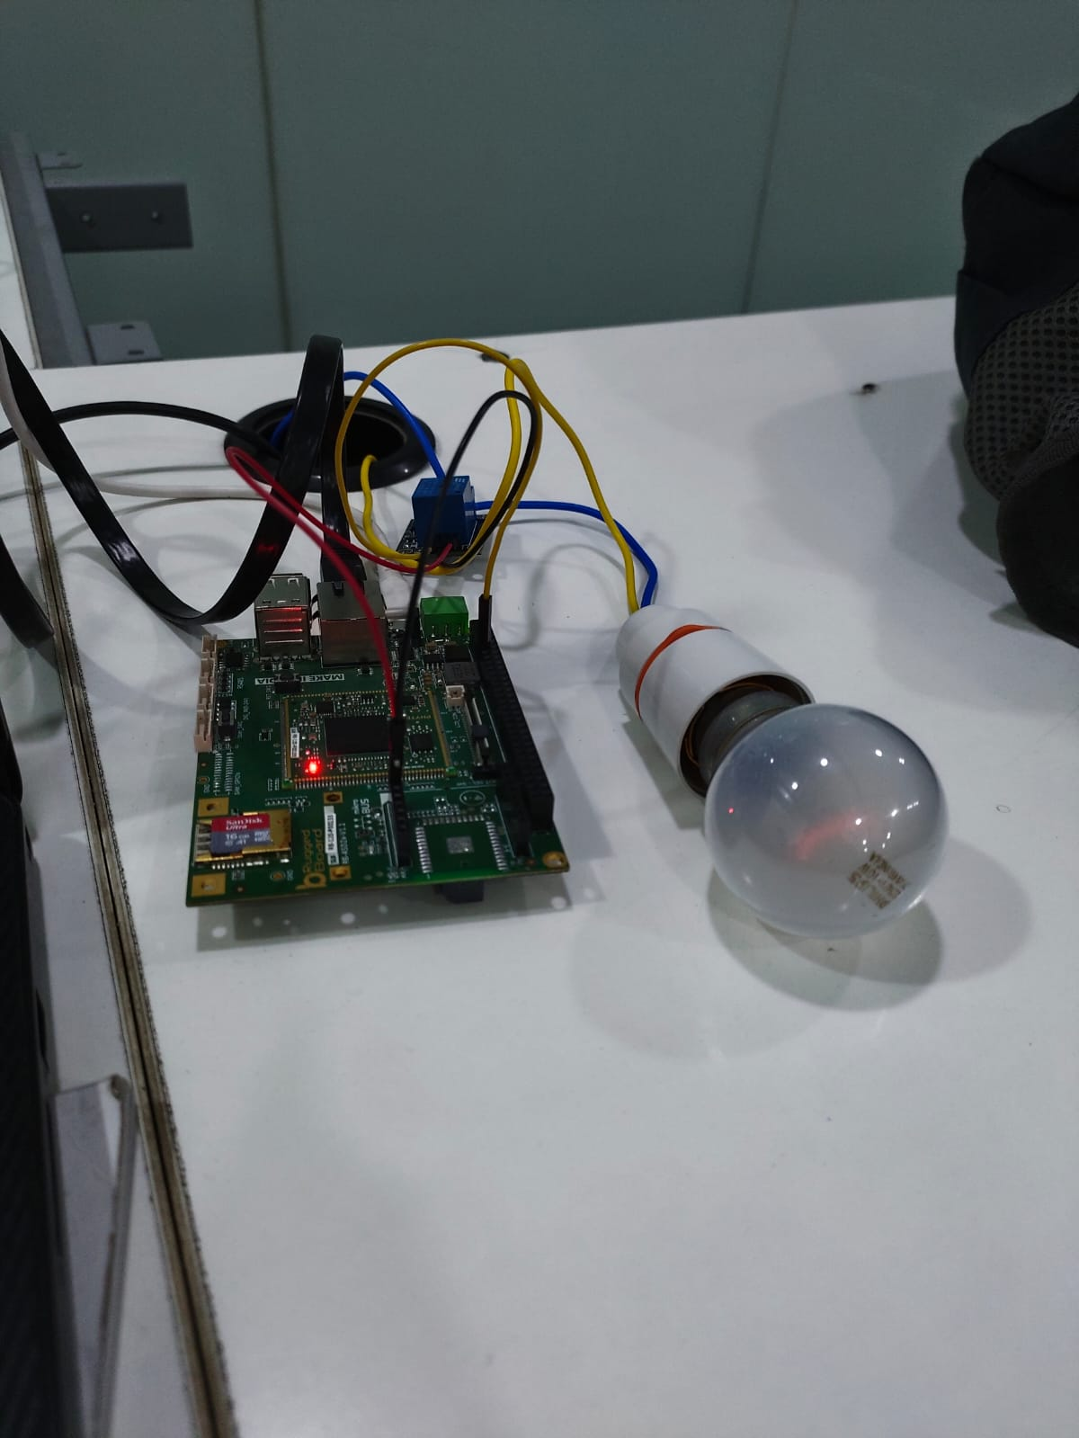

3.5.Output diagram :
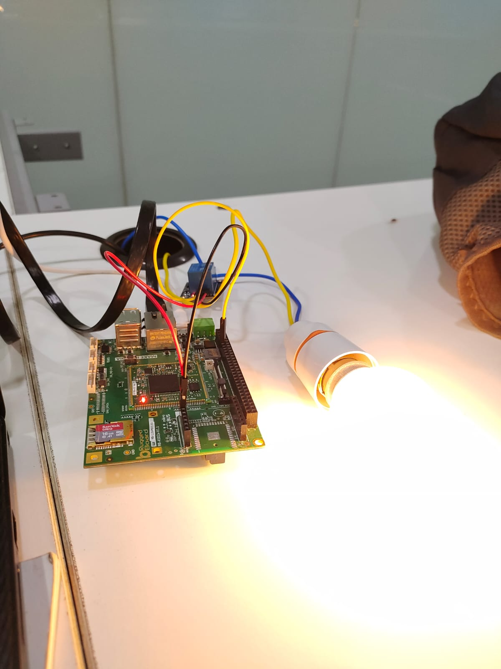

4.STAGE 3
This abstract presents an innovative approach to bulb control using a relay-based system that enhances energy efficiency and user convenience. The proposed system employs a rugged board to intelligently manage the operation of a light bulb through a relay switch. The status of bulb is transmit to the thingsboard.
4.1.Hardware Components
1.Relay.
2.Rugged board.
3.Bulb.

4.2.Connection:
- Now let’s talk about the side that connects to the Rugged board. it has 3 pins
These 3 pins are connected to the microcontroller as shown in below.
- VCC -> 5V
- GND -> GND
- SIGNAL -> PC23 (PIN GPIOA pin as output In Rugged board )

- Now let’s talk about the another side that connects to the bulb. it has 3 pins .
1.COM
2.NO
3.NC.

The connections for the relay is simple. We take a wire from the light bulb and cut it so that we have two separate wires just like it is shown in the picture above as per (fig1) . Then we put one wire into the NO (normally open) pin of the relay, and the other wire into the COM (common) pin of the relay.the status of bulb will be send to the thingsboard through MQTT.

4.3.THINGSBOARD:
ThingsBoard is an open-source Internet of Things (IoT) platform designed to help developers and organizations manage and analyze data from connected devices. It provides a scalable and customizable solution for building IoT applications and services.lets know the h0ow to create thingsboard as shown in below.

how to create device (with MQTT communication)-
Login to thngsboard.
1. for device we have to create device profile only one profile is enough.
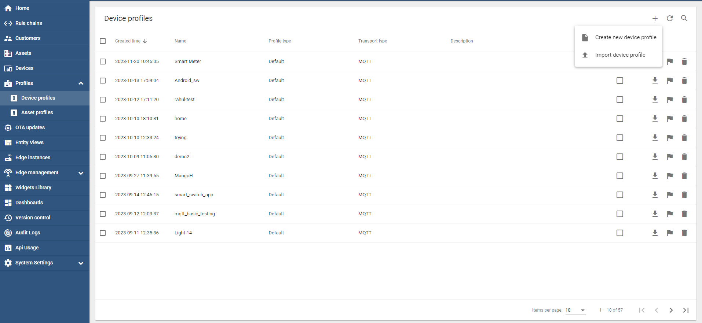
22
1
3

2. give all credential.
User give any name.
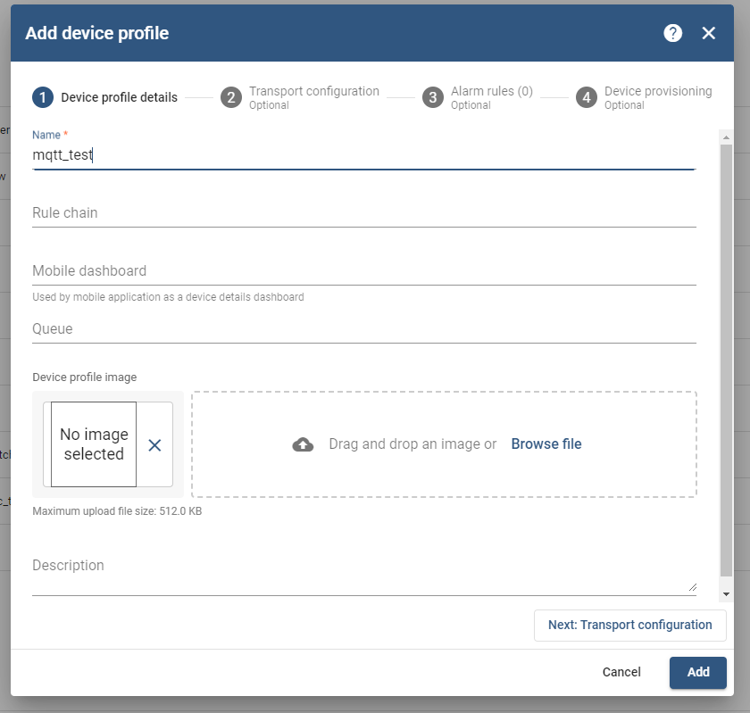
2
1
Next go to Transport Configuration -> Add

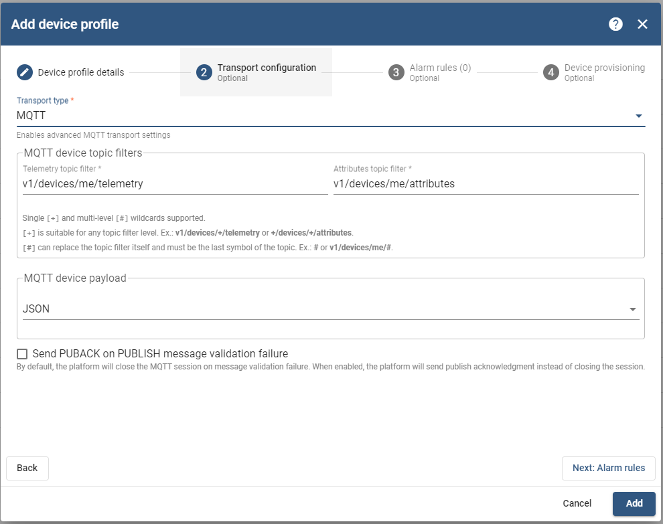
1
2

1. See devices on left side select then create device.
*for communication access token we get from Devices.
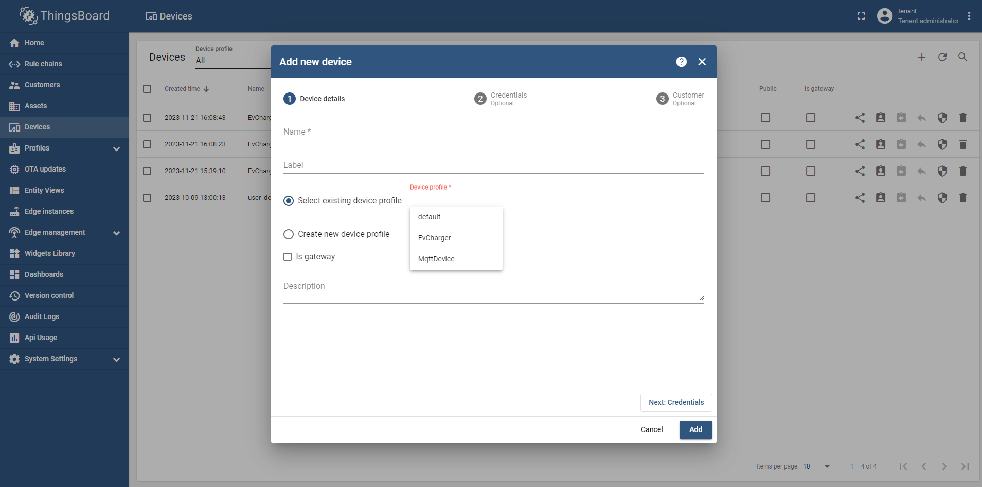
1
2
3

First remove default Device Profile then.
Give the Device profile what we created for mqtt communiocation.
Then click on Add button.
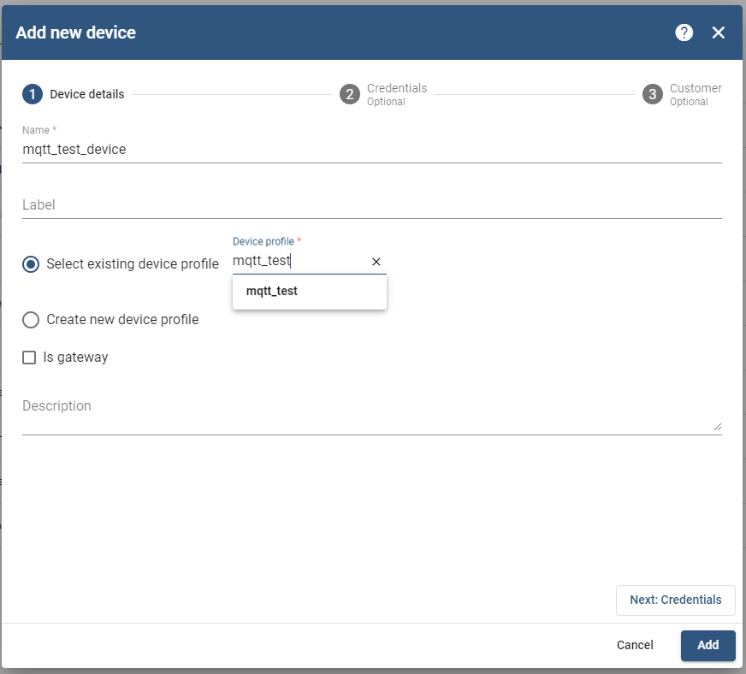
1
2. remember we have to give device profile in all devices what we created.

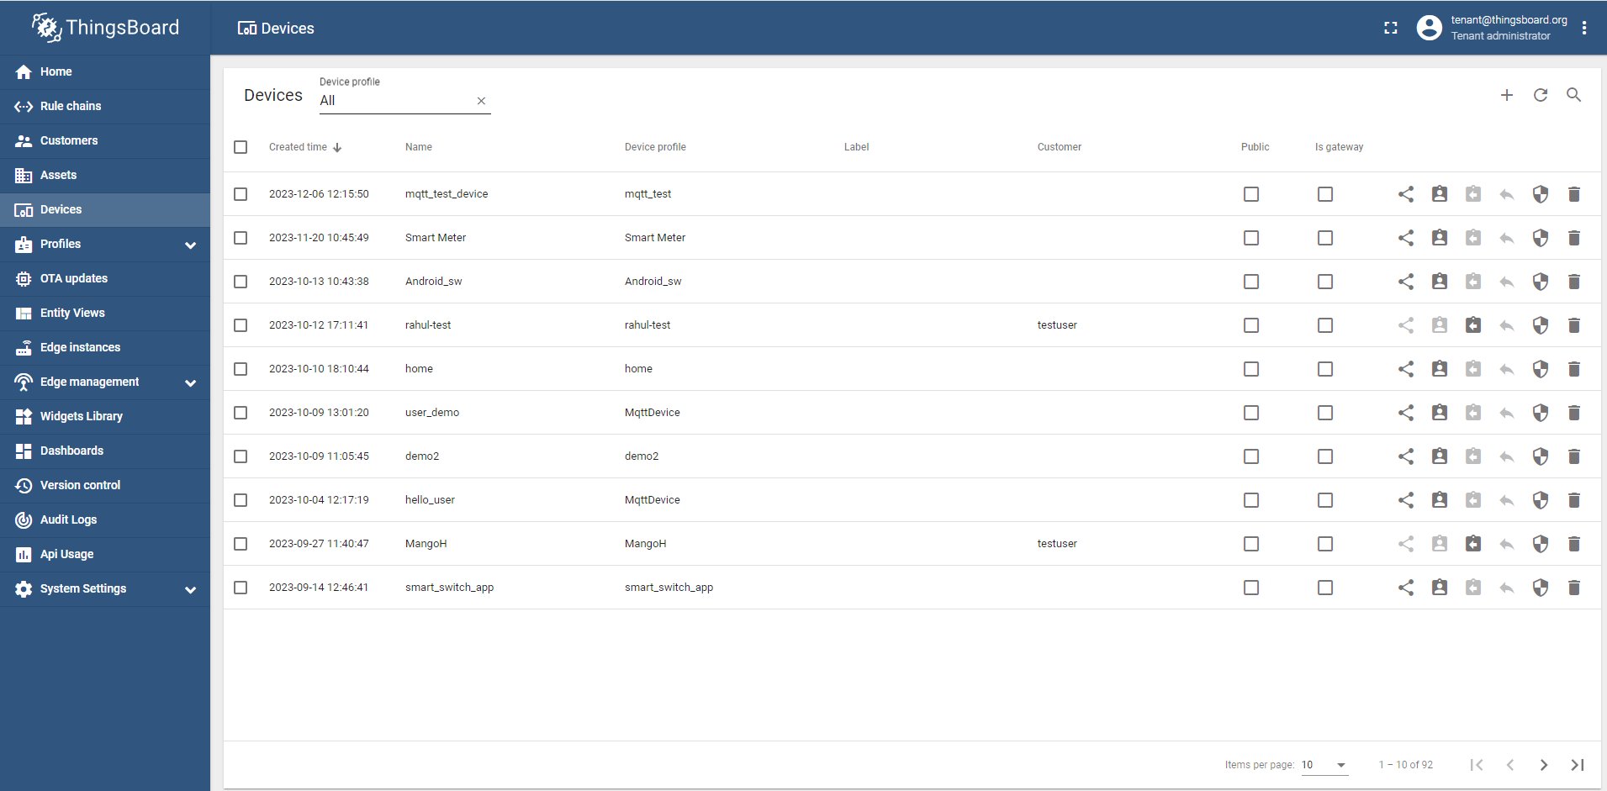
1

Copy access token to connect mqtt.
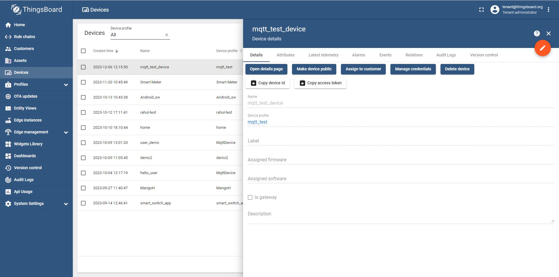
1

To check publish data you have to go into device telemetry –
*only send data into json format only.

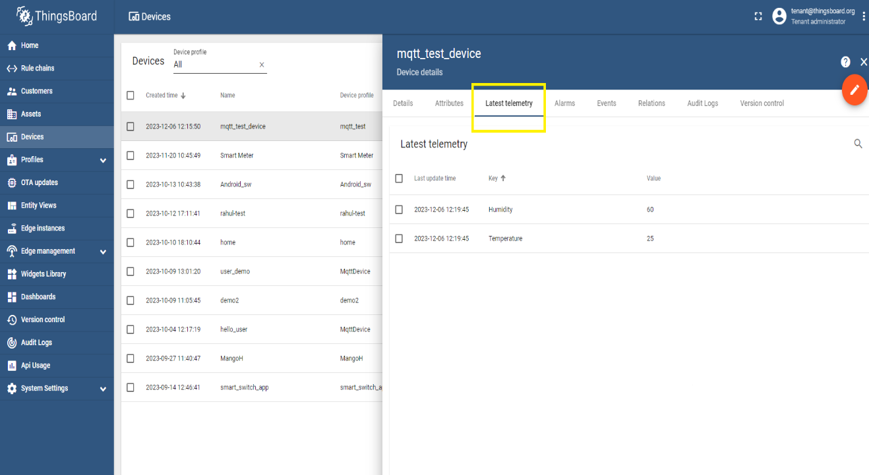
1
2
3

how to create dashboard-
1. select Profiles in profile we see two device profile and asset profile.
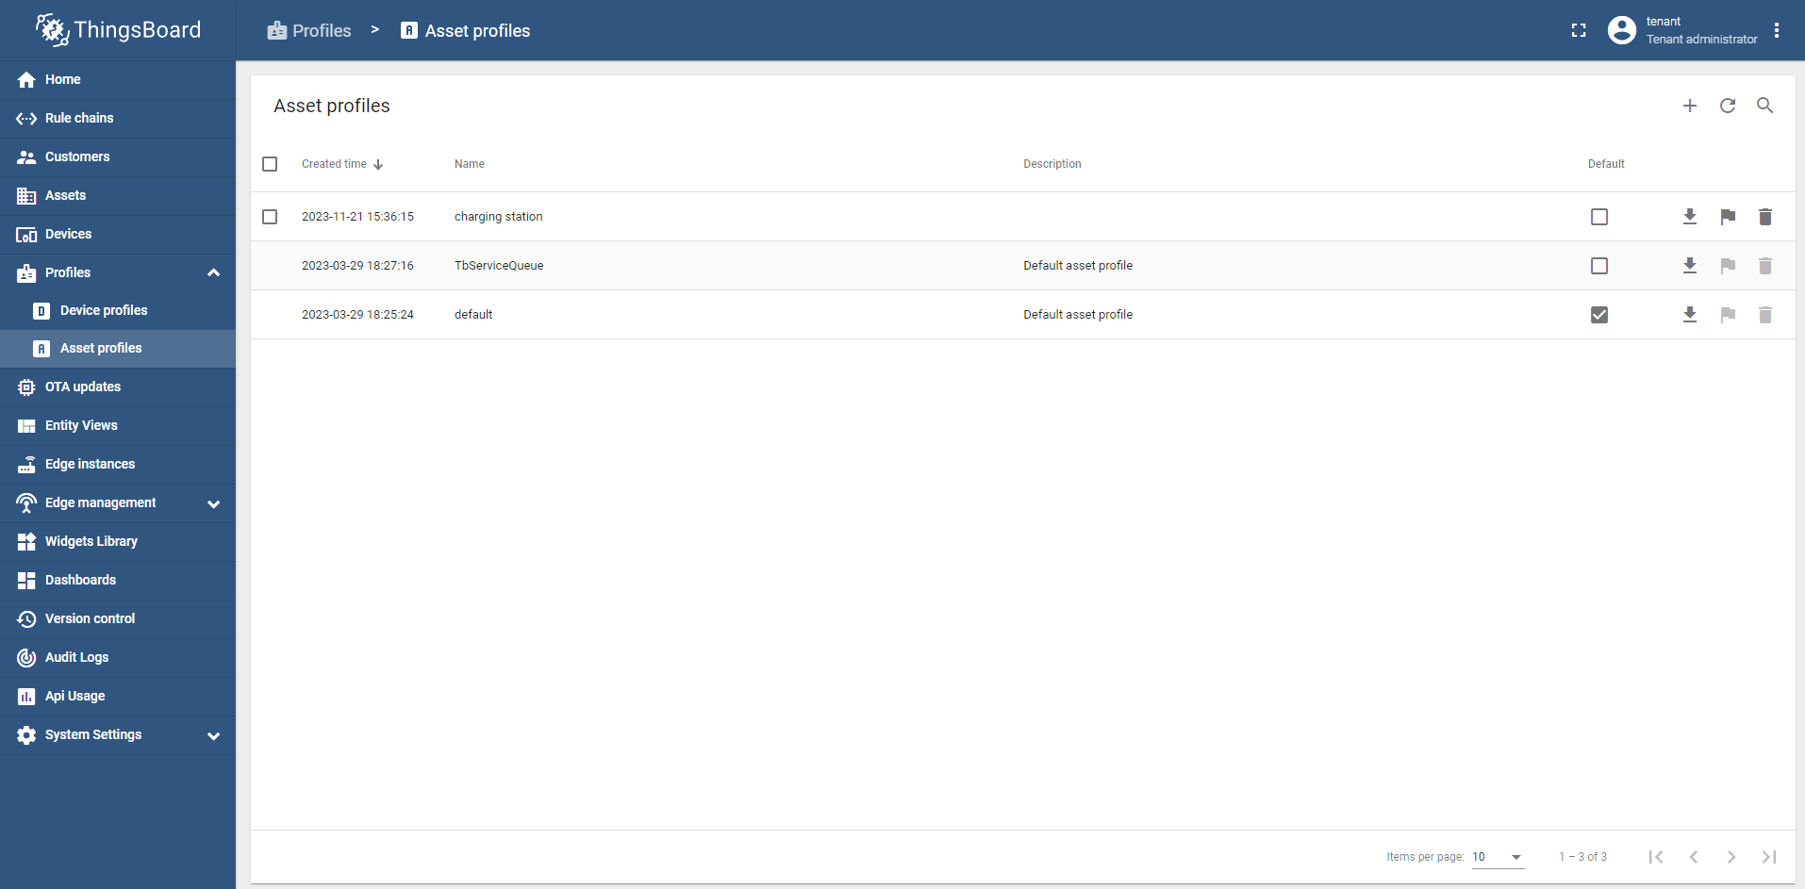
1
2
3
2. go in asset profile and create one asset profile.
1. we see assets on left side select created assets then create assets based on number of ports create assets.
2. now click on asset name then see on top click on attributes in Server attributes add key and value. *we have to do this thing with all assets.

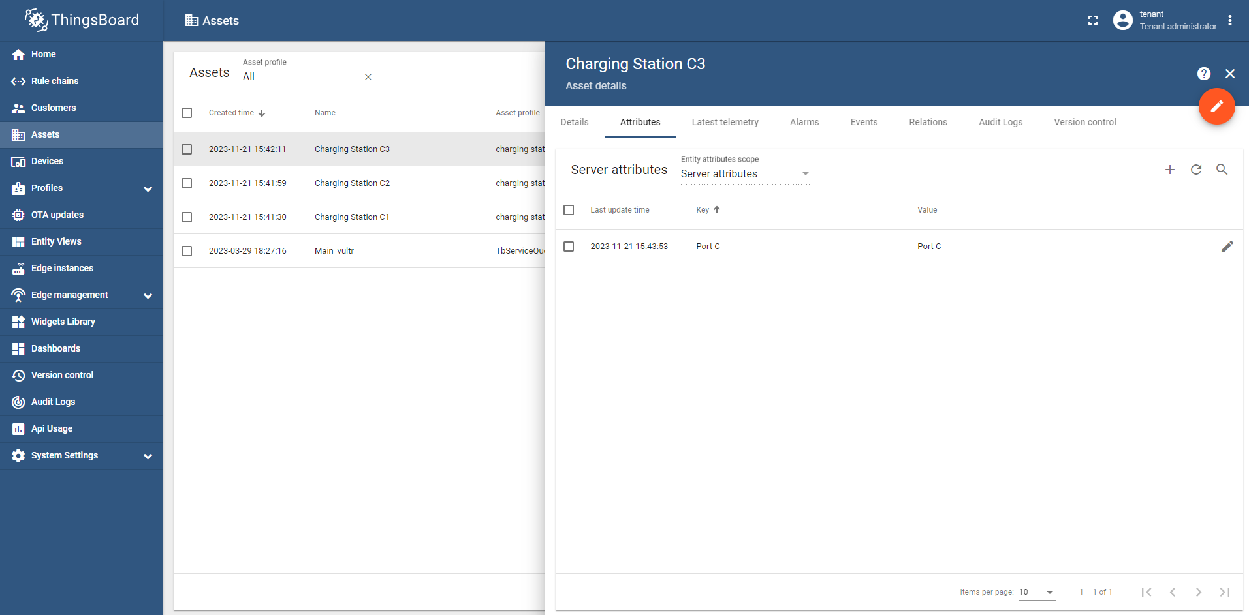
1
2
3
4
5

3. remember we have to give asset profile in all assets what we created.
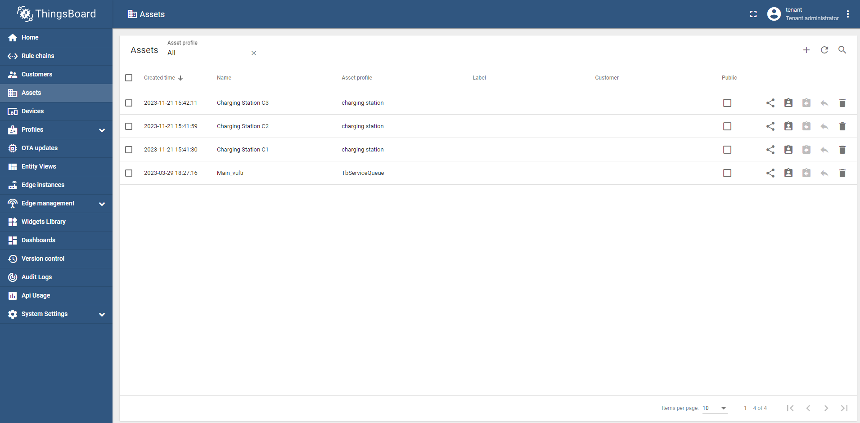

3. for device also we have to create device profile only one profile is enough.

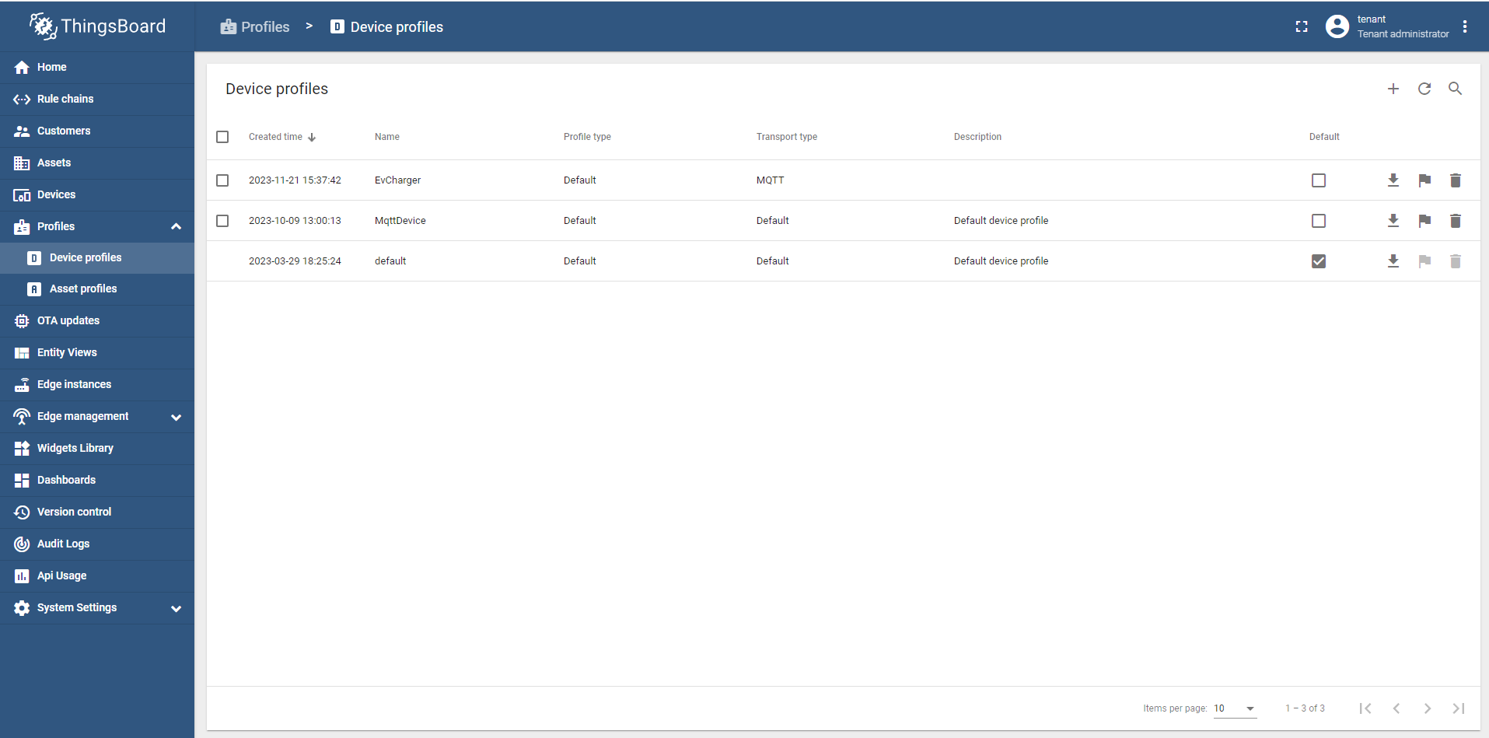
22
1
3

1. we see devices on left side select then create devices based on number of ports create device.
*for communication access token we get here.
1
1
1
2. remember we have to give device profile in all devices what we created.

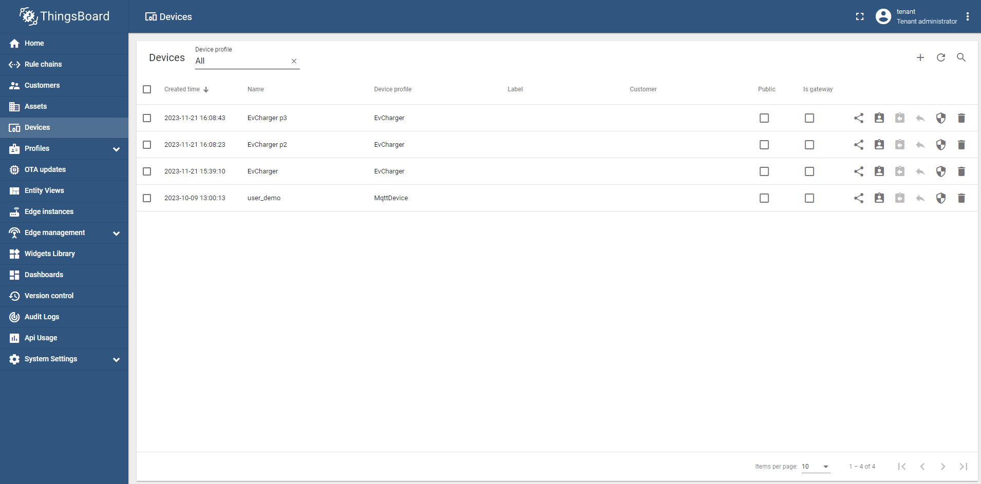
4. click on dashboard in left side-
1. create new dashboard.
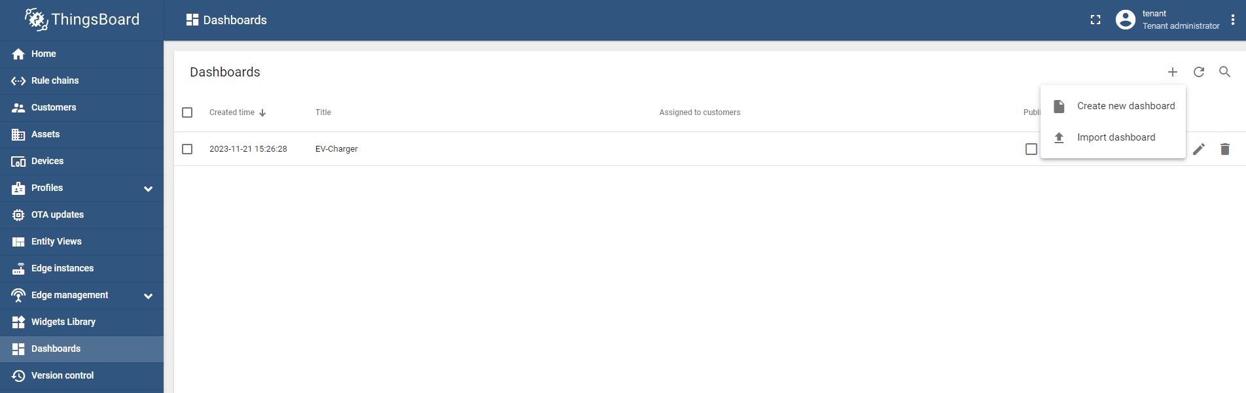
1
2. give dashboard name.
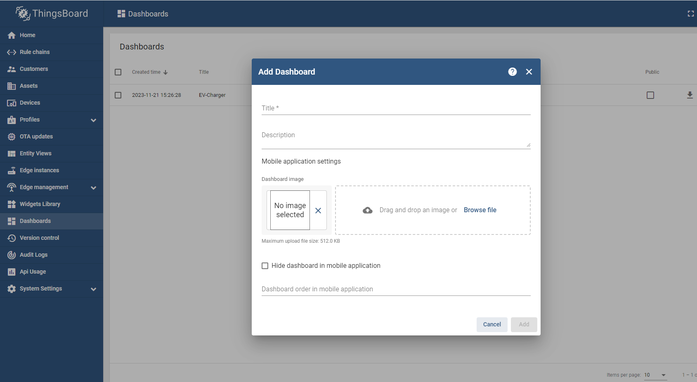
2
3. create entity alias.

1. In the upper right corner of the window, click the “Entity alias” icon.
2. In the opened Entity aliases window, click the “Add alias” button on the left side of the dialog box.
3. In the opened dialog Add alias, enter a name for the alias, select a Single entity filter type. From the Type drop-down menu, Select the Device and enter the name of the needed device (start typing it and it will be found automatically).
4. After configuring the alias, click the “Add” button in the lower right corner.
5. We can now see that a new alias has been added. Click “Save” in the lower right corner of the dialog box.

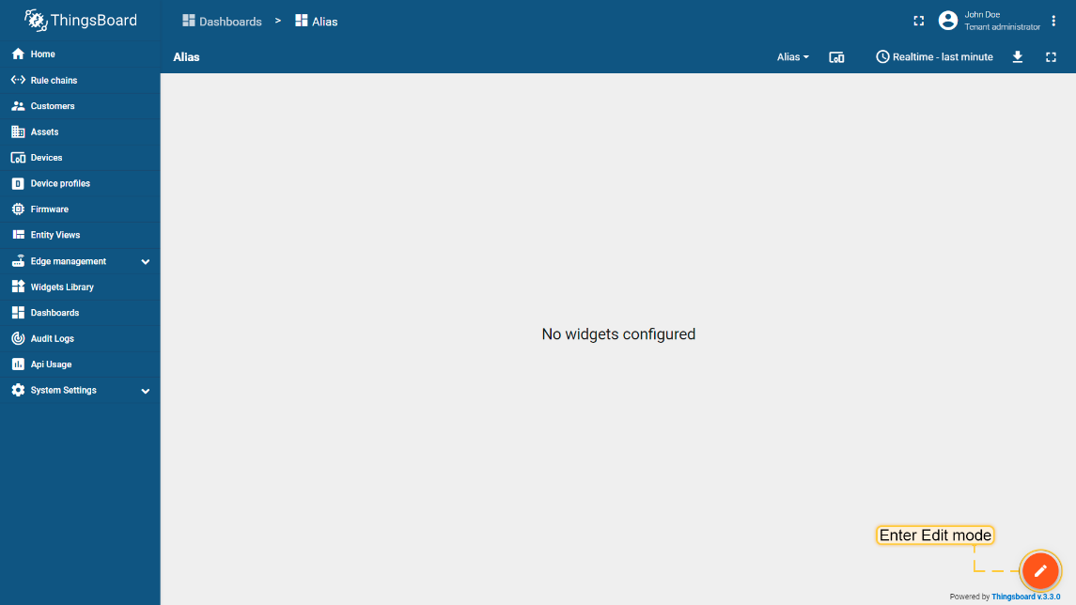

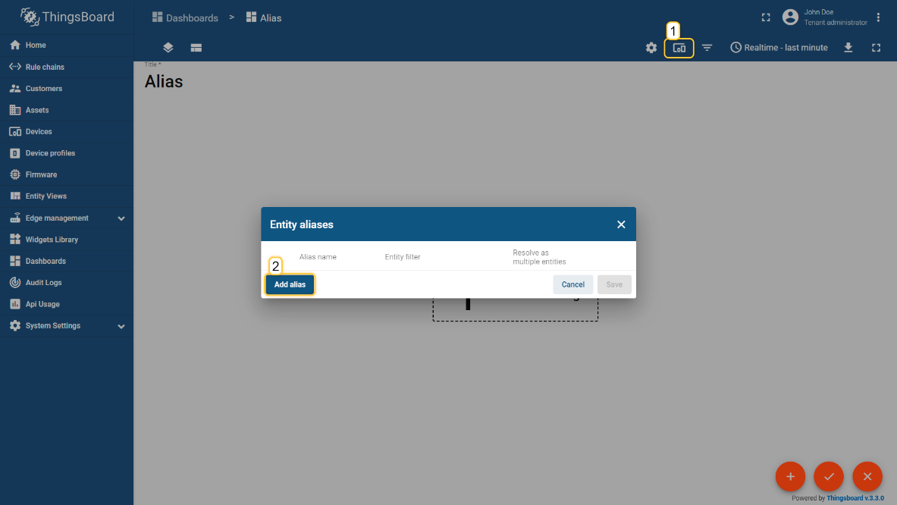

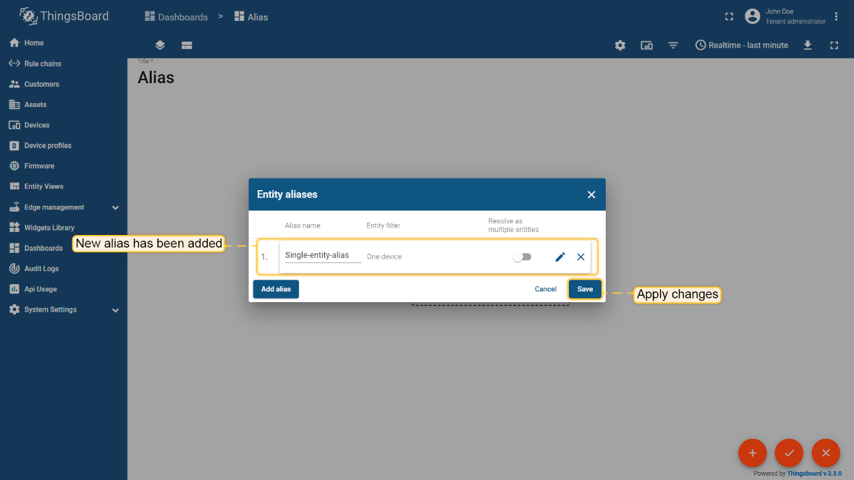
After add Entity aliases click on edit option.
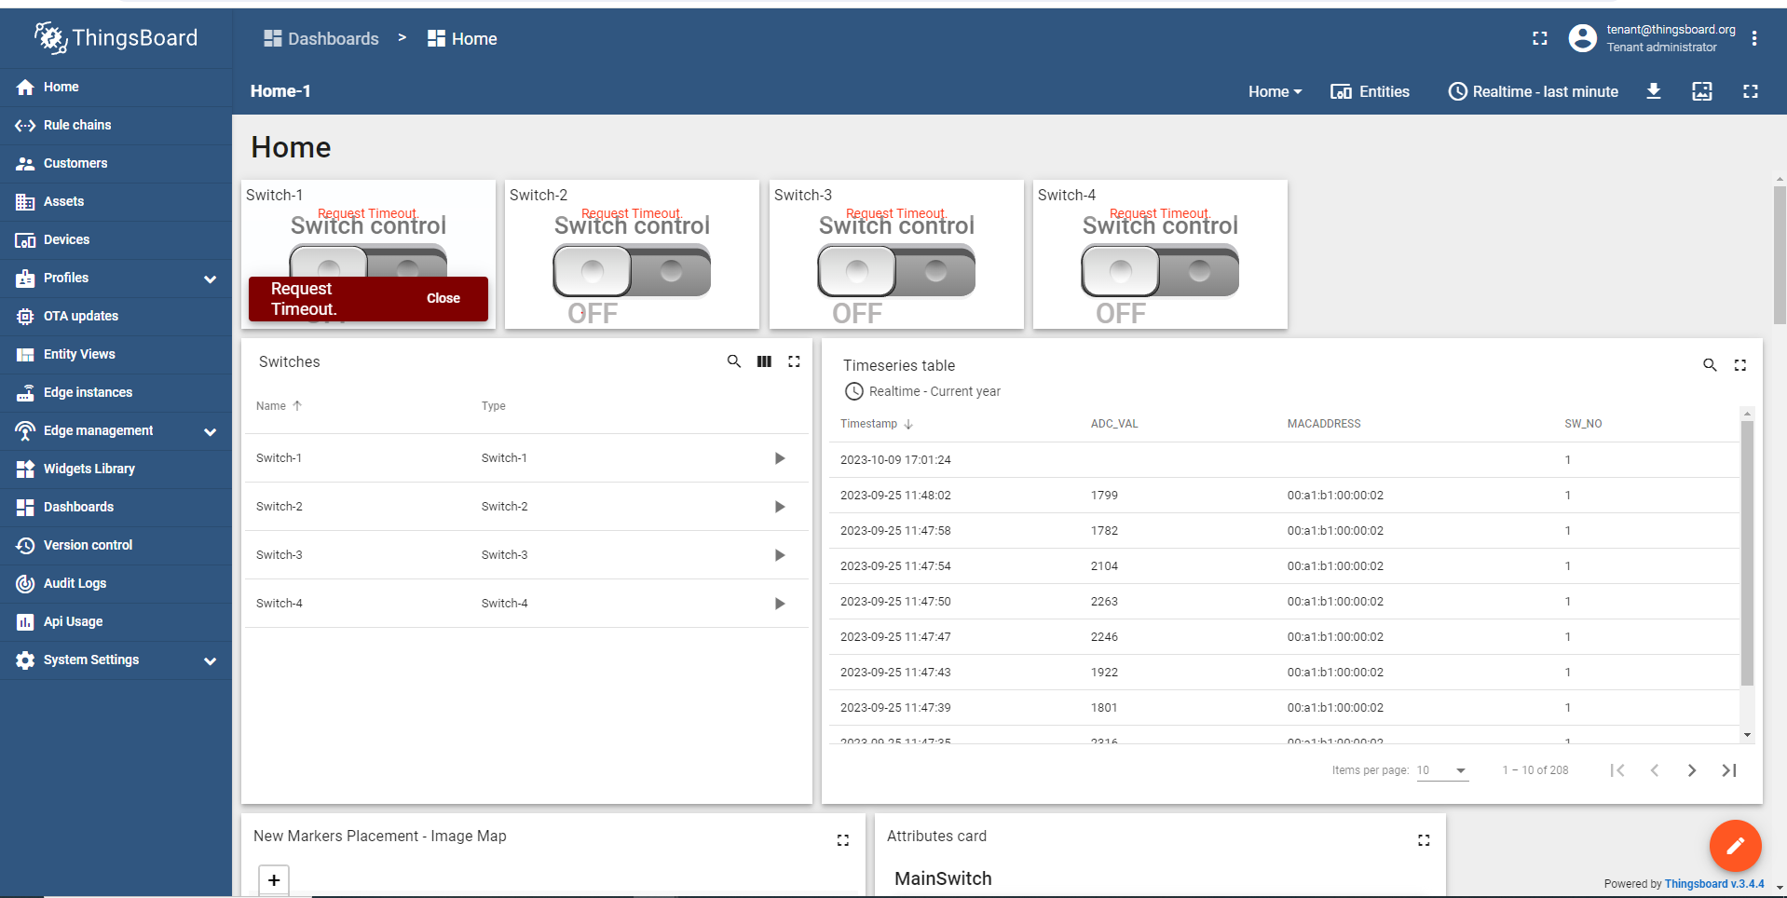
1
Click on Add option.
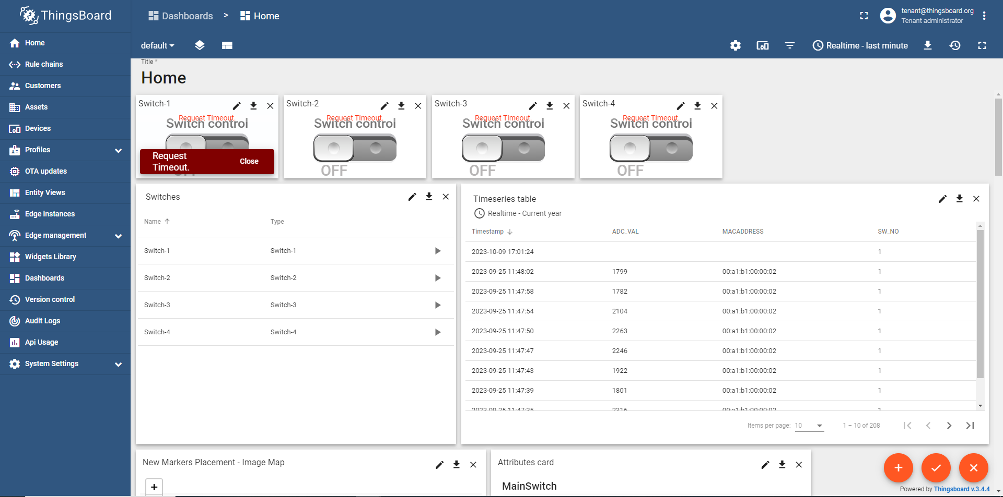
2

Then you can see the create new widget option which is second -> click on that.
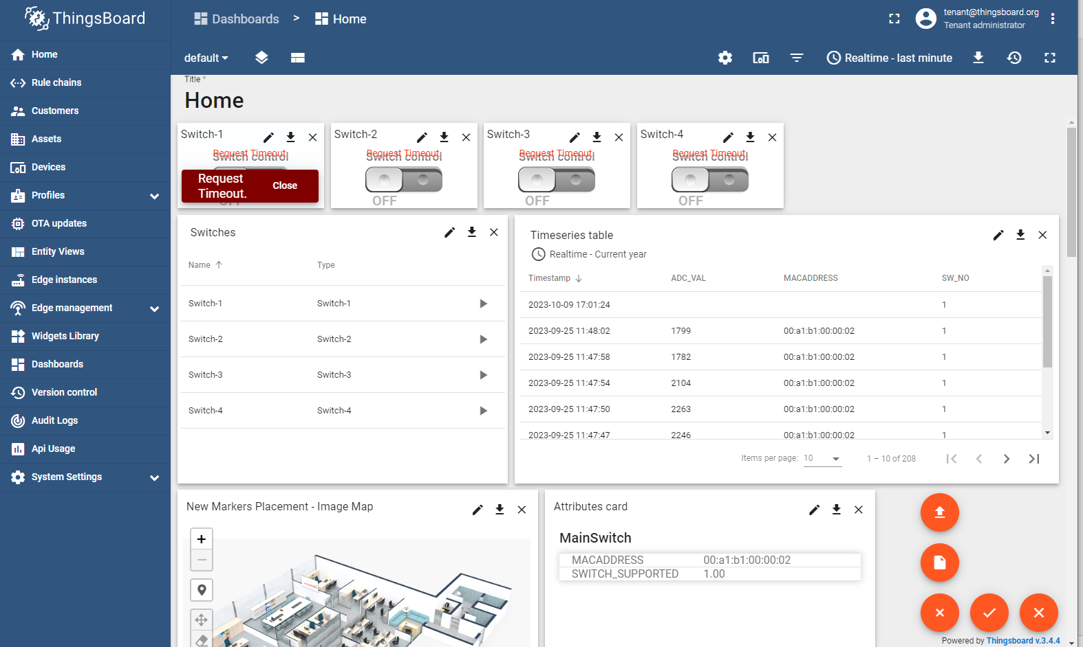
3

Select Control Widgets for select -> Switch Control.
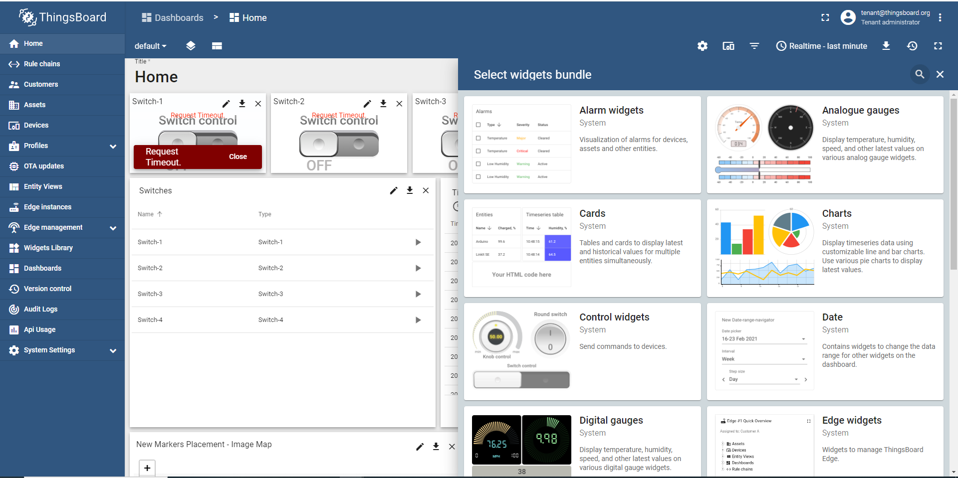
4
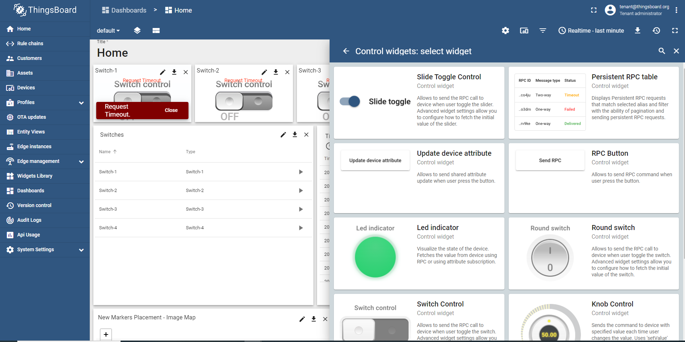
55
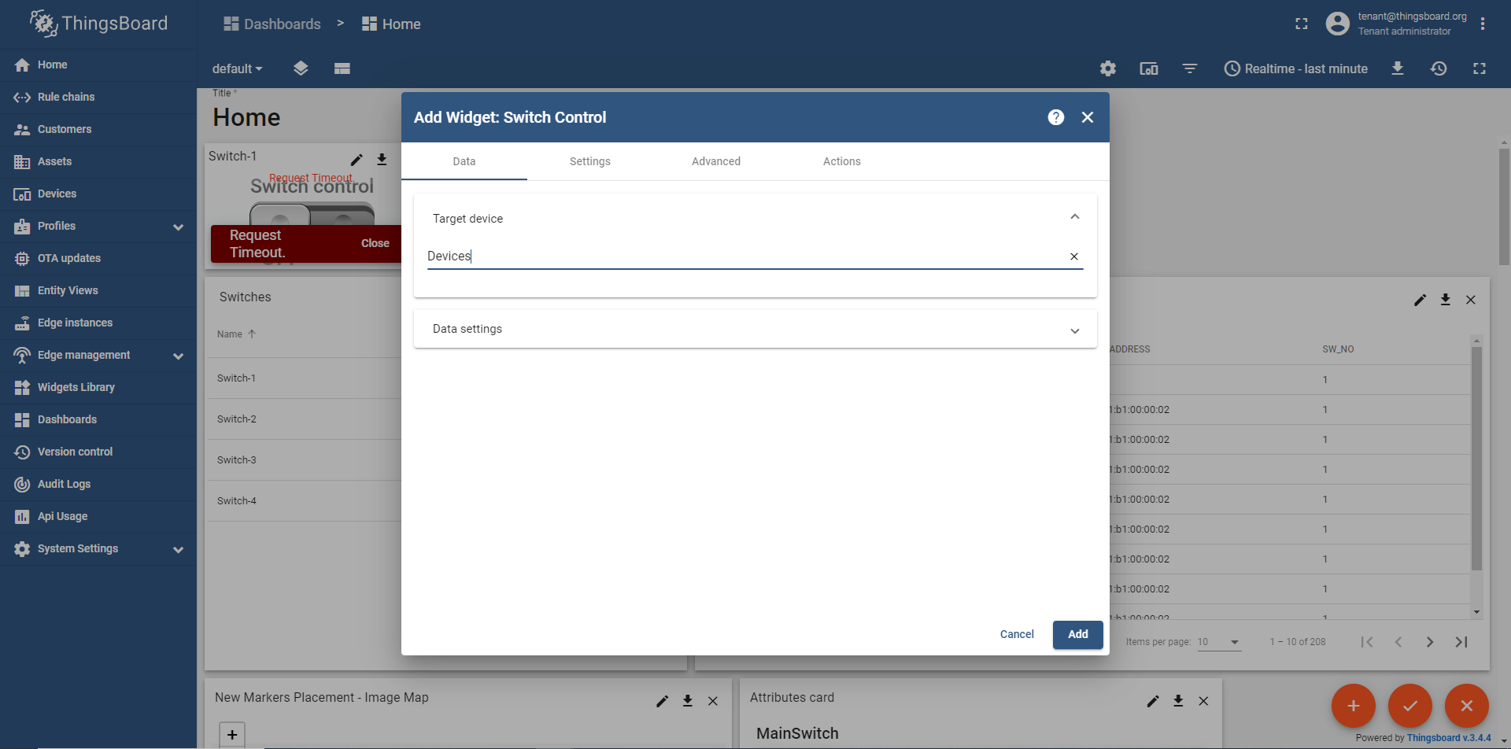
6
7

In Advance give a Json format to send the data.
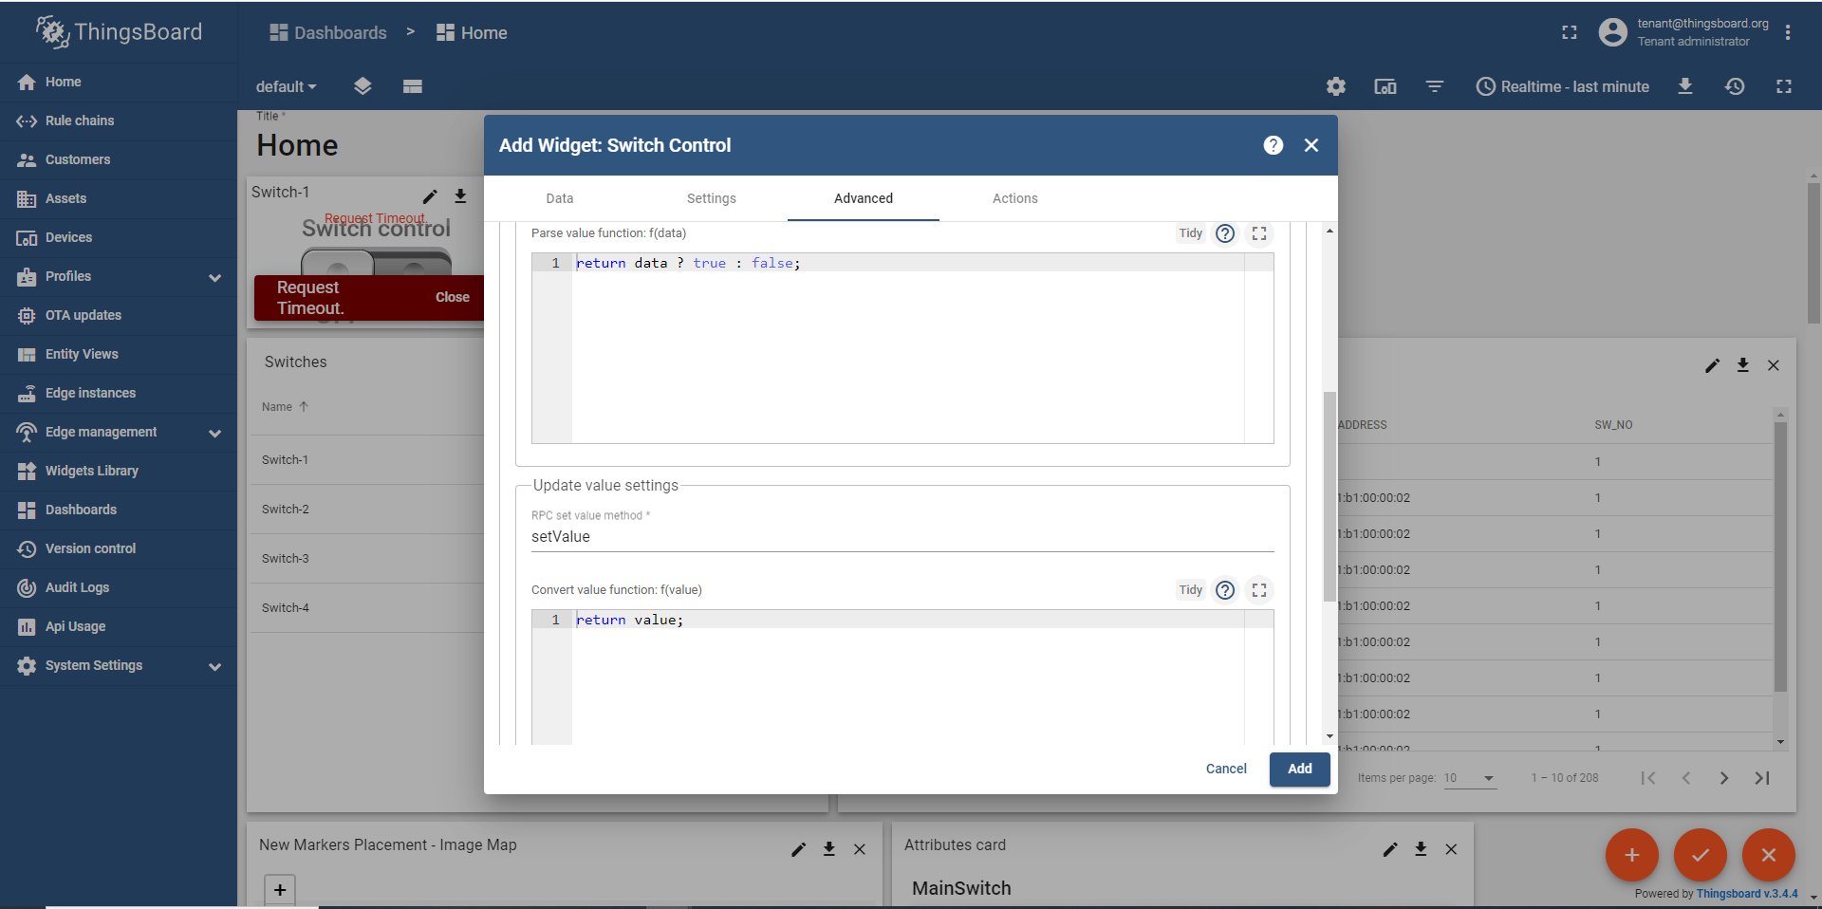
8
9

As you can see how I given here and save it-
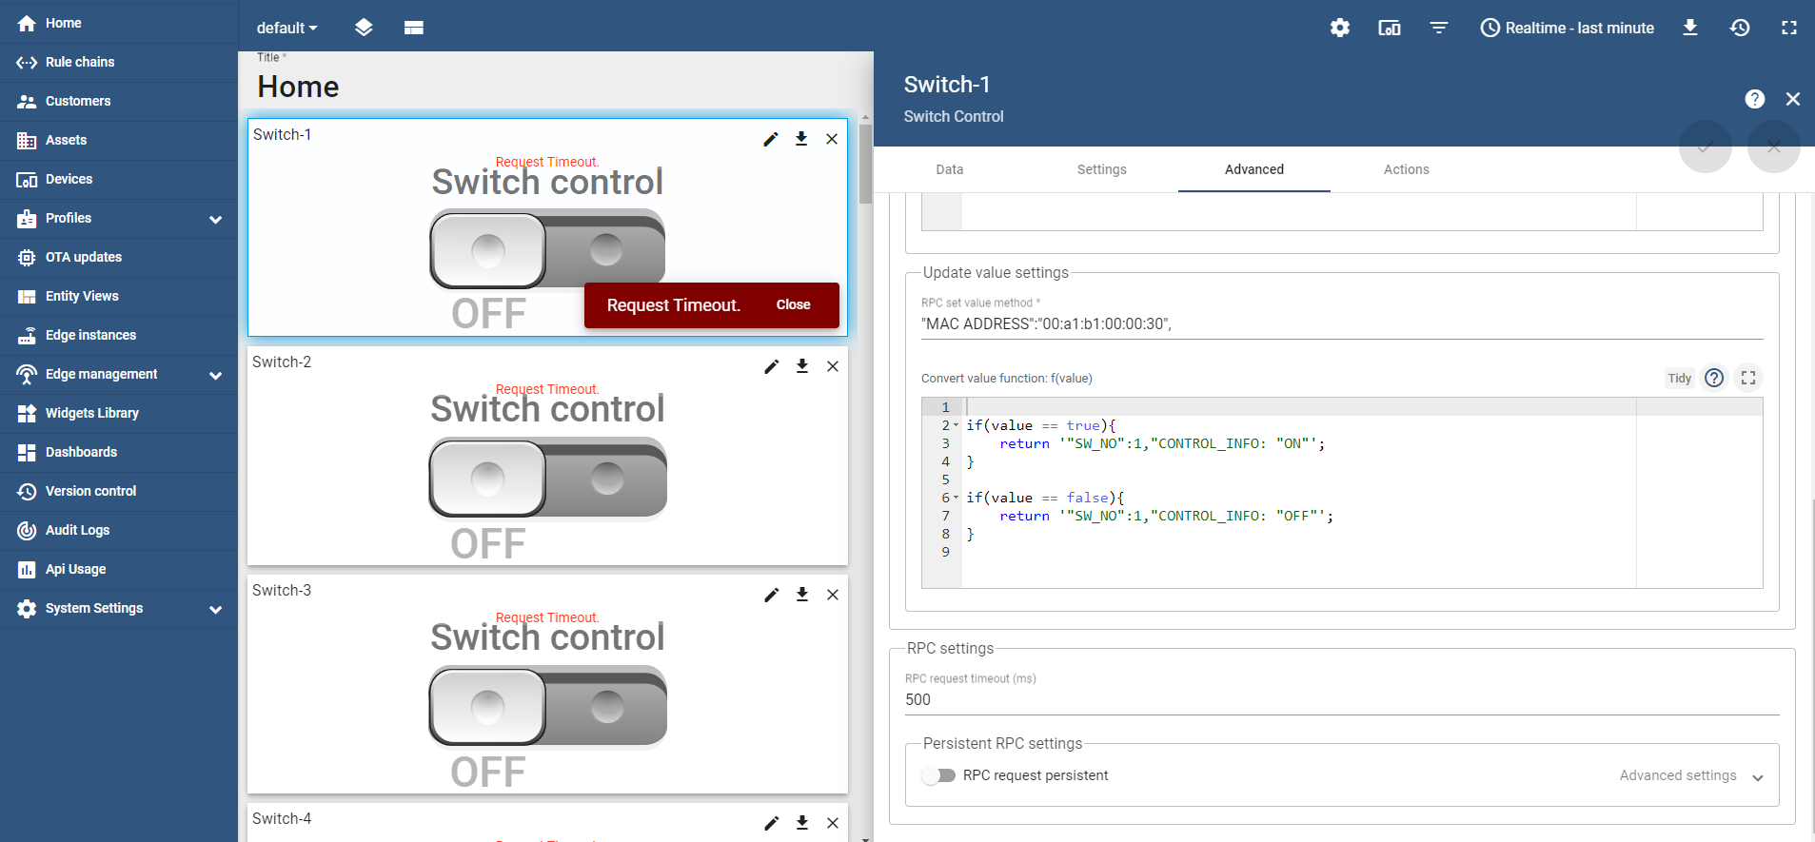

4.4.Source code
#include <stdio.h>
#include <stdlib.h>
#include <string.h>
#include <unistd.h>
#include <fcntl.h>
#include <termios.h>
#include <math.h>
#include "MQTTClient.h"
#define RELAY_PIN_PATH "/sys/class/gpio/PC23/value"

// MQTT Settings
#define ACCESS_TOKEN "SUMcuWGc31jDxIqGoONE"
#define MQTT_ADDRESS "tcp://phyclouds.com:1884"
#define MQTT_CLIENTID "iiscSmartSwitch"
#define MQTT_TOPIC "v1/devices/me/telemetry"
#define MQTT_QOS 1

// Global MQTT client variable
MQTTClient client;
MQTTClient_connectOptions conn_opts = MQTTClient_connectOptions_initializer;

// Function to publish data to MQTT
void publishToMQTT(char *topic, char *payload)
{
MQTTClient_message pubmsg = MQTTClient_message_initializer;
pubmsg.payload = payload;
pubmsg.payloadlen = strlen(payload);
pubmsg.qos = 1;
pubmsg.retained = 0;
MQTTClient_deliveryToken token;

MQTTClient_publishMessage(client, topic, &pubmsg, &token);
MQTTClient_waitForCompletion(client, token, 1000);

int rc = MQTTClient_waitForCompletion(client, token, 10000);

if (rc == MQTTCLIENT_SUCCESS)
{
// Print information about the published data
printf("Published MQTT data - Topic: %s, Payload: %s\n", topic, payload);
}
else
{
fprintf(stderr, "Failed to publish file data. Return code: %d\n", rc);
}
}

// Function to set relay state
void setRelayState(int state)
{
FILE *fp = fopen(RELAY_PIN_PATH, "w");
if (fp == NULL)
{
perror("Error opening relay pin");
exit(EXIT_FAILURE);
}

fprintf(fp, "%d", state); // Writing 0 turns the relay off, 1 turns it on
fclose(fp);
}

int main()
{
// MQTT initialization
MQTTClient_create(&client, MQTT_ADDRESS, MQTT_CLIENTID, MQTTCLIENT_PERSISTENCE_NONE, NULL);
conn_opts.keepAliveInterval = 20;
conn_opts.cleansession = 1;
conn_opts.username = ACCESS_TOKEN;

if (MQTTClient_connect(client, &conn_opts) != MQTTCLIENT_SUCCESS)
{
fprintf(stderr, "Failed to connect to MQTT server\n");
return -1;
}

while (1)
{

setRelayState(1);
printf("Relay is ON\n");
// Publish the relay status to ThingsBoard
char mqtt_payload[500];
snprintf(mqtt_payload, sizeof(mqtt_payload), "{\"RelayStatus\": ON}");
publishToMQTT(MQTT_TOPIC, mqtt_payload);
sleep(2);
setRelayState(0);
printf("Relay is OFF\n");
snprintf(mqtt_payload, sizeof(mqtt_payload), "{\"RelayStatus\": OFF}");
publishToMQTT(MQTT_TOPIC, mqtt_payload);
sleep(2);

}

// Cleanup MQTT resources
MQTTClient_destroy(&client);

return 0;
}

4.5.Output diagram

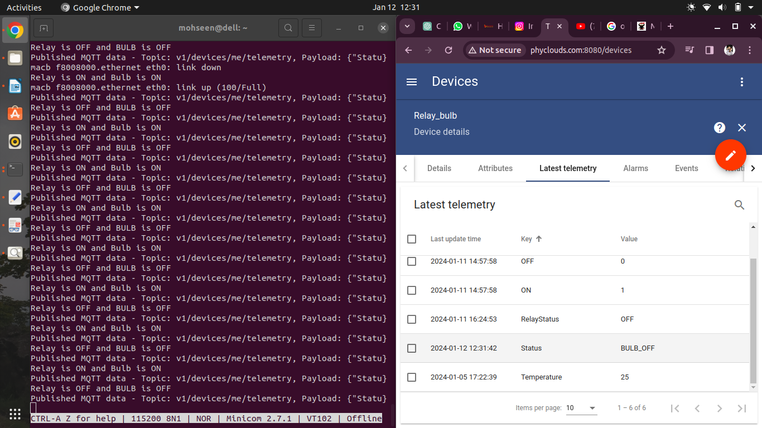

5.conclusion
In summary, implementing bulb control using a relay offers a flexible, efficient, and customizable solution that aligns with modern trends in home automation and IoT. It represents a practical application of technology to enhance convenience, energy efficiency, and overall control of lighting systems.

Presented By
D PHANIDHAR
SK MOHSEEN
K PRAMEELA

